Outreach and Education Materials

Outreach and Education Packet for:
Chronic Care Management (CCM),
Medicare Diabetes Prevention Program (MDPP),
and Preventive Services Education (PSE)

Created August 31, 2022

Point of Contact:
J15 Provider Outreach and Education Team
Email: J15_PartB_Education@cgsadmin.com

Table of Contents
Introduction 3
Target Audiences 3
What’s Included in This Packet? 3
Accessing the Promotion Materials 4
Promotion Materials 4
Materials for CCM 4
Drop-In Text 4
Email 4
Canva Graphics and GIFs 6
Social Media Ads 7
Flyer 8
Videos 9
Materials for MDPP 10
Drop-In Text 10
Email Texts 10
Canva Graphics and GIFs 12
Social Media Ads 13
Flyer 14
Videos 15
Materials for PSE 16
Drop-In Blurbs 16
Email Texts 17
Canva Graphics and GIFs 18
Social Media Ads 19
Flyer 20
Videos 21

Outreach and Education Materials Packet for CCM, MDPP, and PSE

Introduction
This promotion packet provides outreach and communications materials to help the Center for Medicare & Medicaid Services (CMS) and Medicare Administrative Contractors boost awareness and engagement among providers and eligible Medicare patients with the following Medicare programs/services:
- Chronic Care Management
- Medicare Diabetes Prevention Program
- Medicare Wellness Visits

Target Audiences

The materials included in this packet are meant to reach primary care providers; however, OB/GYNs may also benefit from receiving messaging about MDPP.

What’s included in this packet?
This document includes the following promotion materials, which you can edit or customize:
- Drop-In Text: Text to drop into an existing email or print newsletter or to place on your website
- Email: Standalone emails to send directly to enrolled providers and practice managers/practice leadership
- Graphics: Graphics to pair with any of the other promotion materials (e.g., include a graphic alongside text in an email or with a social media post)
  - Please note: Many graphics were created with the online design platform, Canva. Links to edit the graphics on Canva are provided (e.g., the CGS logo may be swapped out for another logo).
- Social Media Ads: Content and graphics to use across social media platforms; while they are designed as ads, you can modify them to use as social posts.
- Flyers: PDFs flyers to disseminate digitally or in print
- Videos: Brief videos to link to or to embed in any of the promotional materials above

Helpful Tip: It is strongly recommended that you create bit.ly links to track clicks in all outreach materials. Visit bit.ly.com to get started.

Accessing the Promotion Materials
This document contains copies of promotion materials for your reference. You can access all items on the CGS website.

Promotion Materials

Materials for CCM

Drop-In Text

CCM Drop-In Text 1
Care Coordination Support for Patients With Chronic Illnesses
Chronic Care Management (CCM) is care coordination services, conducted outside of regular office visits, for people with 2+ chronic conditions. CCM helps providers deliver coordinated care to improve patient health, increase satisfaction with their care, and make care more person centered. Providers can bill for CCM services when at least 20 minutes of clinical staff time are spent on delivering CCM services per month. Check out this booklet for more information on CCM, including the requirements, elements, and billing guidance.

CCM Drop-In Text 2
Approximately $\frac{2}{3}$ of people with Medicare have 2+ chronic conditions, which means they can benefit from Chronic Care Management (CCM)—care coordination services conducted outside of regular office visits for people with multiple chronic conditions who have Medicare. Practitioners can use separate billing codes when at least 20 minutes a month of clinical staff time (directed by a physician or other qualified health care professional) are spent on delivering CCM services. This video summarizes the elements of CCM and may be a helpful tool for explaining CCM to your clinical staff and even eligible patients.

Email

CCM Email 1
Subject line: Find out how CCM can benefit your practice and patients with chronic diseases
Medicare program can help practices manage chronic conditions and improve efficiency
Chronic Care Management (CCM) is the care coordination services provided outside of regular office visits to patients on Medicare with multiple chronic conditions. These services routinely require extra time and resources for providers and clinical staff.
Patient and Practice Benefits of CCM
With CCM, patients will gain:
- A health care professional team to help them plan for and stay on track for good health
- A comprehensive care plan to help support disease control and health management goals
- Support needed between health care visits
Some providers have reported that making CCM services available to their patients has helped to improve practice efficiencies, enhance patient satisfaction and compliance, and decrease hospitalization and emergency department visits. In addition, providers can bill Medicare when at least 20 minutes of CCM services are provided in a month.
Learn more about CCM
The Connected Care Toolkit is a helpful resource for health care professionals and communities, providing information about CCM services and payment, its benefits for providers and patients, eligibility criteria, and how to get started with implementing it in your practice. Also included are talking points for discussing CCM with staff and for explaining CCM to patients, as well as links to more resources.

CCM Email 2
Subject line: Providing Coordinated Care to Patients with Chronic Illnesses
Making Coordinated Care Happen: Benefits to Your Patients and Practice
An estimated 117 million Americans have 1 or more chronic health conditions, including heart disease and cancer, which are among the leading causes of death in the United States. Chronic Care Management (CCM) can be part of the solution to improve the care and health of people with these conditions.
What is CCM?
CCM is care management services that routinely require extra time outside of regular office visits for Medicare patients with 2 or more chronic conditions. There are separate billing codes you can use for providing this between-appointment help that your patients need to stay on track with their treatments.
Getting Started With CCM
This printable flyer provides information and resources on CCM, its benefits, and how to start implementing it in your practice. It can also be a helpful resource when discussing CCM with your eligible Medicare patients.
Remember—your clinical staff can deliver these CCM services under your supervision, saving you time and resources!

Canva Graphics and GIFs
1: Link to edit 2: Link to edit
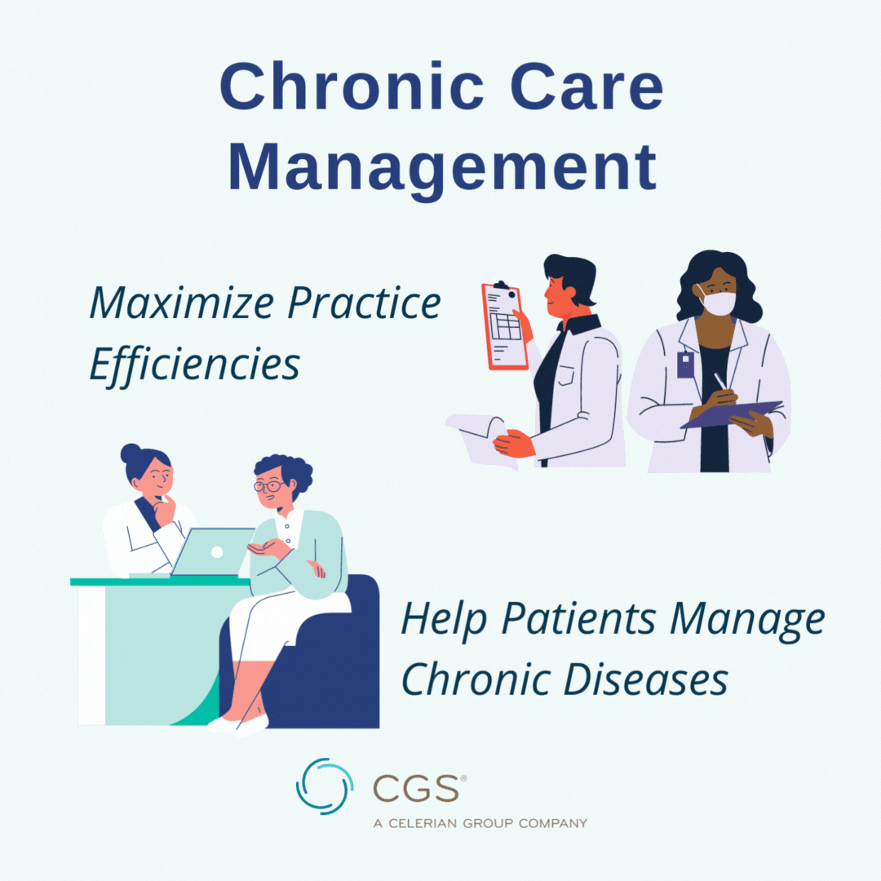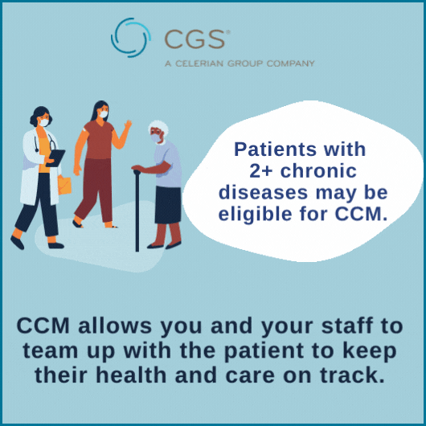
3: Link to edit 4: Link to edit
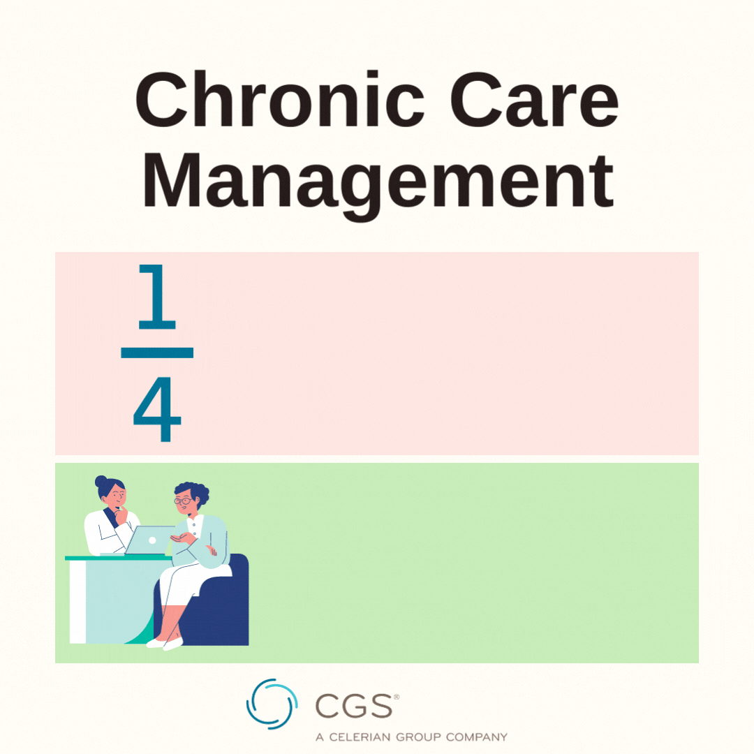

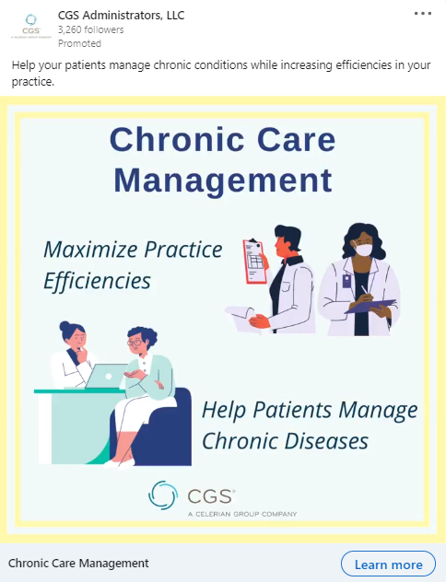
Social Media Ads

CCM Social Media Ad 1
Primary Text (92 characters): Help your patients manage chronic conditions while increasing efficiencies in your practice.
Headline (24): Chronic Care Management
Call to Action (11): Learn more
Link: https://www.cms.gov/About-CMS/Agency-Information/OMH/equity-initiatives/chronic-care-management

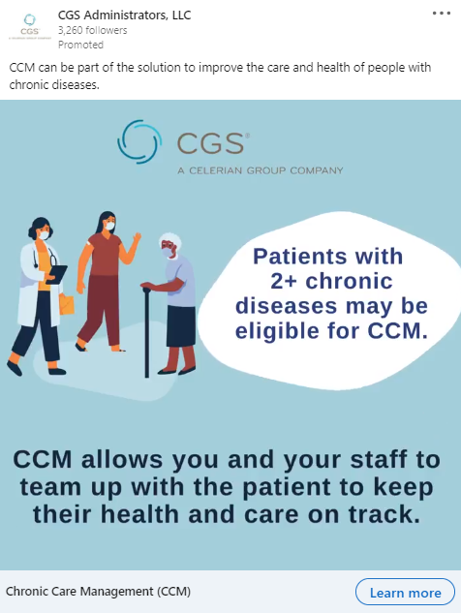

CCM Social Media Ad 2
Primary Text (96 characters): CCM can be part of the solution to improve the care and health of people with chronic diseases.
Headline (24): Chronic Care Management
Call to Action (11): Learn more
Link: https://cgsmedicare.com/pdf/j15/innovations/ccm.pdf

Flyers

CCM Flyer 1
Link: https://cgsmedicare.com/pdf/j15/innovations/ccm.pdf
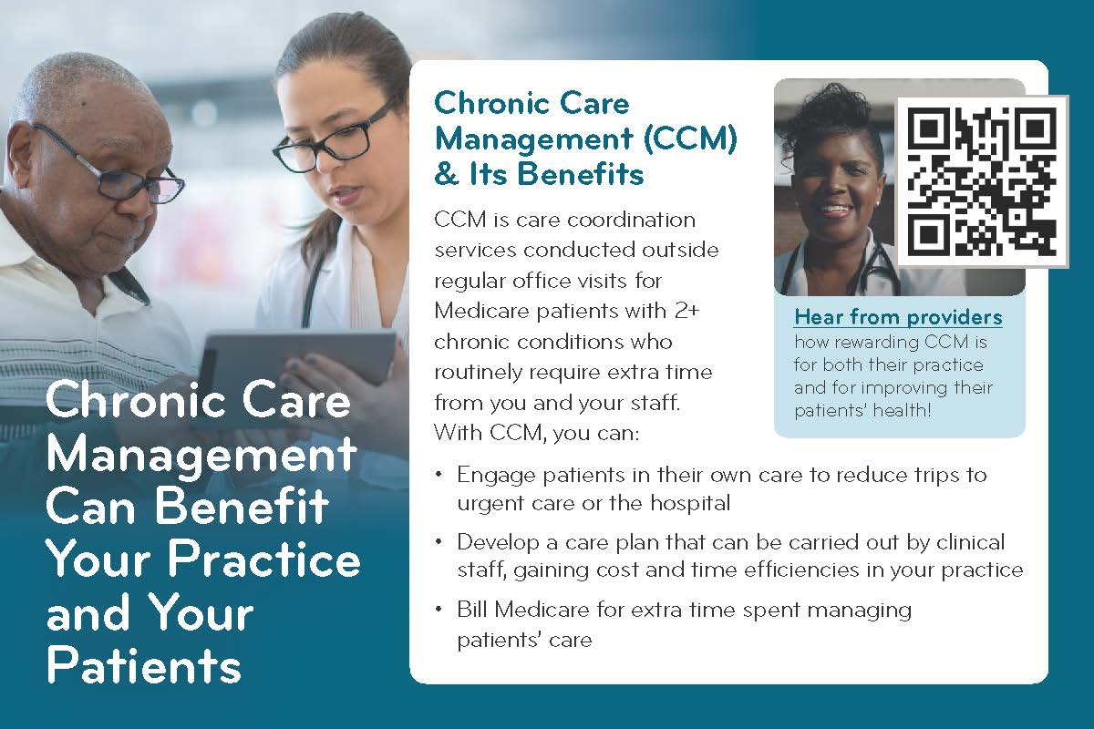
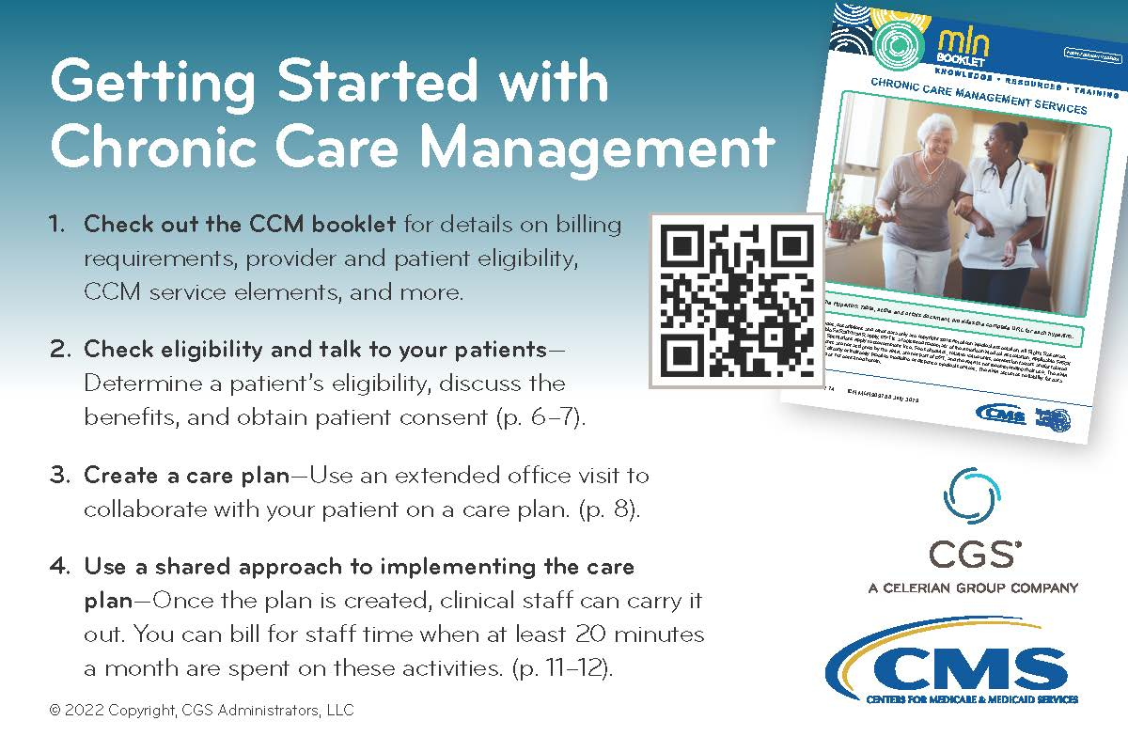

Video

Chronic Care Management: A Critical Primary Care Service
Link: https://www.youtube.com/watch?v=MZJe-BOQJUQ

Materials for MDPP

Drop-In Text

MDPP Drop-In Text 1
Preventing Type 2 Diabetes
The Medicare Diabetes Prevention Program (MDPP) is a lifestyle change program designed to reduce the risk for type 2 diabetes (T2D) among people with prediabetes. It’s modeled after the evidence-based National Diabetes Prevention Program—proven to reduce T2D risk by 71% in people 60+. Providers can help eligible patients enroll in this program by talking to them about it (this flyer can help) and by using this referral map to find an MDPP near them.

MDPP Drop-In Text 2
Help patients combat prediabetes with Medicare program
Referring patients with prediabetes to the Medicare Diabetes Prevention Program (MDPP) may help them delay or prevent the progression of prediabetes to type 2 diabetes (T2D). MDPP is a lifestyle-change program modeled after the evidence-based National Diabetes Prevention Program, which is proven to reduce T2D risk by 71% in people aged 60 and older.
Steps for Referring Patients to MDPP
- Watch this video to find out how you can get patients involved. Hearing from a trusted source of health information can motivate patients to participate.
- Learn about the eligibility requirements, and talk to your patients who qualify. You can also use this referral map, which shows MDPP locations by ZIP Code to help refer patients to an MDPP near them.

Email Texts

MDPP Email 1
Subject line: Medicare patients with prediabetes may be eligible for lifestyle-change program
Refer patients to the lifestyle-change program that can reduce type 2 diabetes risk
The Medicare Diabetes Prevention Program (MDPP) is an intervention designed to delay or stop the progression to type 2 diabetes (T2D) among people with prediabetes. MDPP is modeled after the evidence-based National Diabetes Prevention Program, which is proven to reduce T2D risk by 71% in people aged 60 and older.
Refer patients to get them enrolled
Eligible patients can self-refer to MDPP, but hearing from you—a trusted source of health information—can motivate them to participate. Check out this printable flyer, which provides resources and information on the elements of MDPP, benefits for its participants, and how to get your eligible patients involved. You can also use this referral map, which shows MDPP locations by ZIP Code, to help you refer patients to a MDPP near them.
More than 1/3 of Americans have T2D. Refer patients to MDPP to help them achieve lifestyle changes necessary to reduce their risk for T2D and other serious health complications!

MDPP Email 2
Subject line: Combatting Type 2 Diabetes With a Lifestyle-Change Program
Lifestyle-Change program can reduce risk for type 2 diabetes
The Medicare Diabetes Prevention Program (MDPP) is an intervention designed to delay or prevent the progression of prediabetes to type 2 diabetes, through group-based, practical training in long-term dietary change; increased physical activity; and behavior change strategies for weight control.
About MDPP
MDPP includes up to 22 group sessions over a 12-month period, available at no cost for people with Medicare. It’s modeled after the evidence-based National Diabetes Prevention Program, which is proven to reduce type 2 diabetes risk by 71% in people aged 60 and older.
This printable flyer summarizes the elements of MDPP, benefits for its participants, and how to get patients involved.
Getting Patients to Participate
Provider referral to MDPP is not required for patient enrollment, but hearing from a trusted source of health information can motivate them to participate. Learn about the eligibility requirements, and talk to your patients who qualify. You can also use this referral map, which shows MDPP locations by ZIP Code, to help you refer patients to a MDPP near them.

Canva Graphics and GIFs
1: Link to edit 2: Link to edit
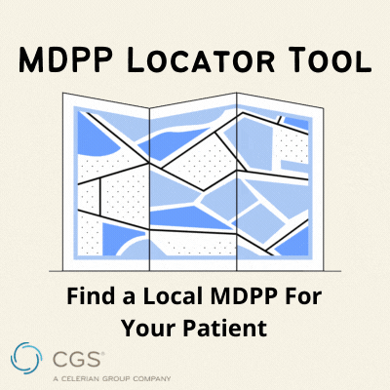



Social Media Ads

MDPP Social Media Ad 1
Primary Text (98 characters): Refer patients with prediabetes to the evidence-based Medicare Diabetes Prevention Program (MDPP)!
Headline (17): Find a local MDPP
Call to Action (11): Learn more

Link: https://innovation.cms.gov/innovation-models/medicare-diabetes-prevention-program/mdpp-map



MDPP Social Media Ad 2
Primary Text (126): The evidence-based Medicare Diabetes Prevention Program (MDPP) can reduce risk for type 2 diabetes in people with prediabetes.
Headline (21): What does MDPP offer?
Call to Action (11): Learn more
Link: https://cgsmedicare.com/pdf/j15/innovations/mdpp.pdf

Flyer

MDPP Flyer 1
Link: https://cgsmedicare.com/pdf/j15/innovations/mdpp.pdf
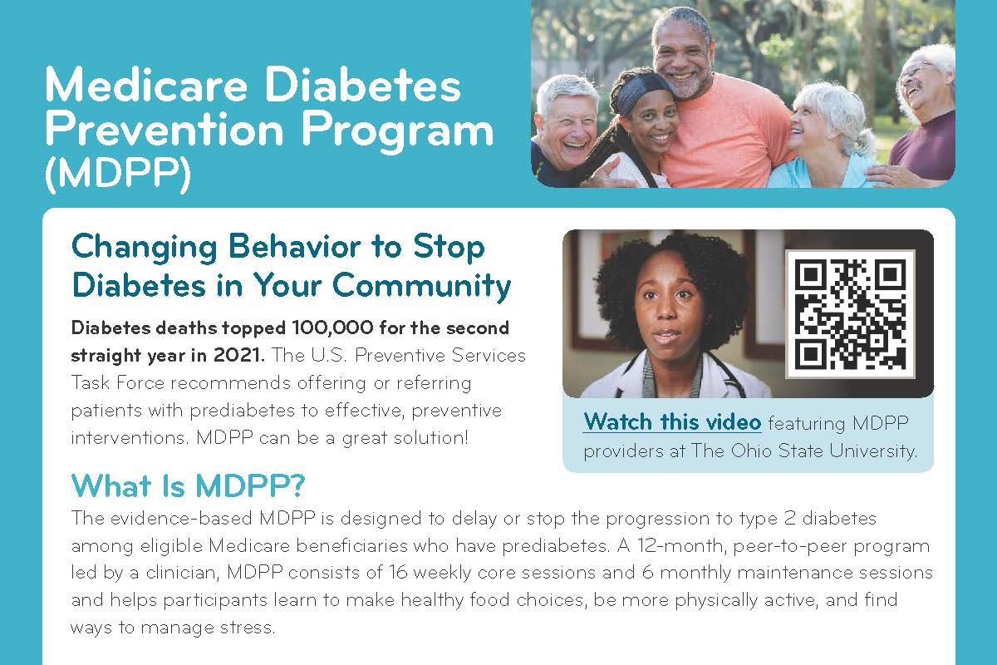
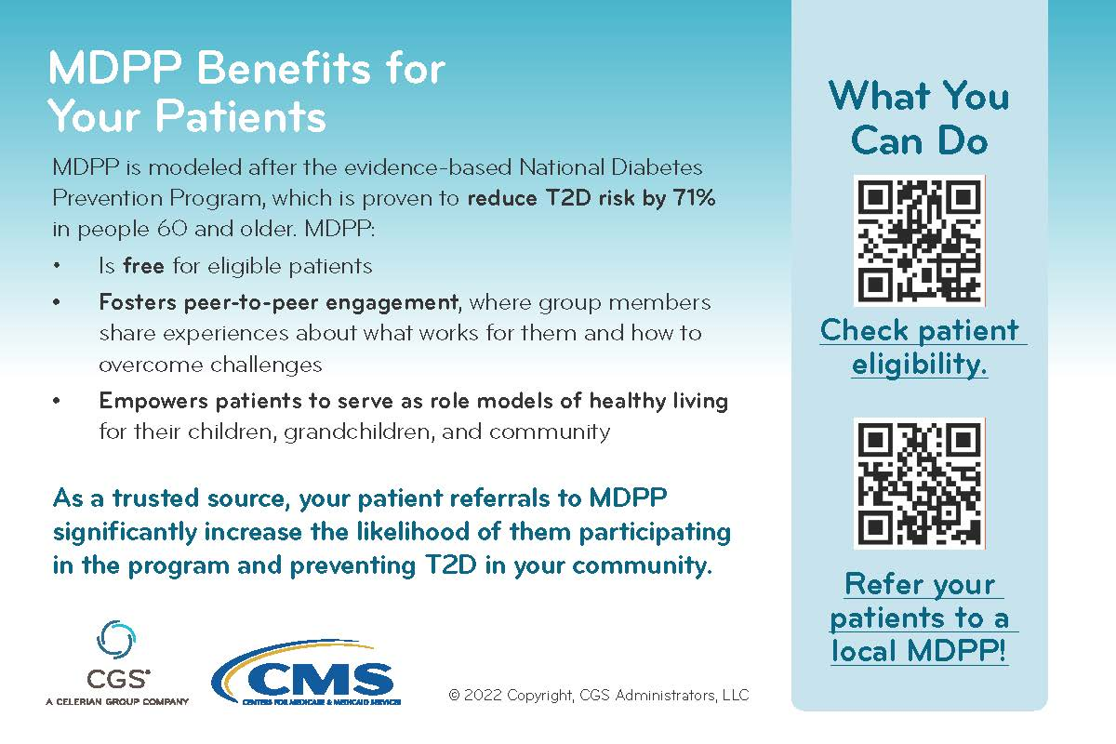

Videos

Becoming a Medicare Diabetes Prevention Program (MDPP) Supplier
Link: https://www.youtube.com/watch?v=FG2zUXIwUrw

The Medicare Diabetes Prevention Program (MDPP) Explained
Link: https://www.youtube.com/watch?v=mSex_FrEXZ4

Materials for PSE

Drop-In Blurbs

PSE Drop-In Text 1
Steps to Maximizing Efficiency for Medicare Wellness Visits
Medicare wellness visits provide an opportunity to identify illness and to plan for other preventive services. There are 3 types of visits covered by Medicare:
- Initial Preventive Physical Exam
- Initial Annual Wellness Visit (AWV)
- Subsequent AWVs
To help reduce claims denials, check out this video summarizing the components of each visit, when to offer them, and which billing codes to use when submitting claims for them. This downloadable flyer provides the information and tools you need to successfully submit claims and to gain efficiencies in time and resources spent on every visit.

PSE Drop-In Text 2
There are 3 types of Medicare wellness visits that can help prevent or identify illness through screening and plan for other Medicare preventive services, but billing the wrong visit at the wrong time can result in denied claims. To reduce the number of denied claims for Medicare wellness visits, follow these simple steps:
- Step 1: Use myCGS to check when your patient is eligible for a Medicare wellness visit. Checking myCGS can help you confirm patient eligibility and reduce billing errors and unnecessary co-pays for patients.
- Step 2: Create efficiencies by teaming up with clinical staff who can perform the wellness visits—saving you and your patients time and money.
- Step 3: Learn more about the 3 types of wellness visits with this flyer, which explains which visit to use and when and how to submit claims for them.

Email Texts

PSE Email 1
Subject line: Keep your patients on track for wellness visits
Medicare Wellness Visits: Steps to Increased Efficiency and Reimbursement
Medicare wellness visits are an important opportunity for health promotion, disease screening and early detection, and advance care planning. However, billing the wrong visit at the wrong time can result in denied claims.
There are 3 types of Medicare wellness visits: the initial preventive physical exam (IPPE), initial annual wellness visit (AWV), and subsequent AWVs. To avoid denied claims and to gain efficiencies in time and resources spent on these visits, follow these simple steps:
- Step 1: Use myCGS to check when your patient is eligible for a Medicare wellness visit.
- Step 2: Team up with clinical staff (e.g., RNs) who can perform part or all of a wellness visit—saving you and your patients time.
- Step 3: Learn more about the 3 types of wellness visits. And remember, Medicare only covers the IPPE and initial AWV once per lifetime and the subsequent AWVs once per year.
Check out this flyer for a summary of what is included in each Medicare wellness visit, when to provide each visit, and how to submit claims for them.

PSE Email 2
Subject line: Gain efficiencies in your practice when delivering wellness visits
Increase efficiency for Medicare wellness visits in your practice
Three types of Medicare wellness visits offer important opportunities for health promotion, disease screening and early detection, and advance care planning:
- Initial Preventive Physical Exam
- Initial Annual Wellness Visit (AWV)
- Subsequent AWVs
Each wellness visit has its own separate set of billing codes, and billing for the wrong visit at the wrong time can result in denied claims. To avoid this, and to gain efficiencies in time and resources spent on these visits, check out this printable flyer. It includes a summary of the main components of each Medicare wellness visit, when to provide each visit, and which billing codes to use.
And remember, your clinical staff, like medical assistants, can help you by conducting these visits with eligible Medicare patients, saving you time and resources!

Canva Graphics and GIFs
1: Link to edit 2: Link to edit
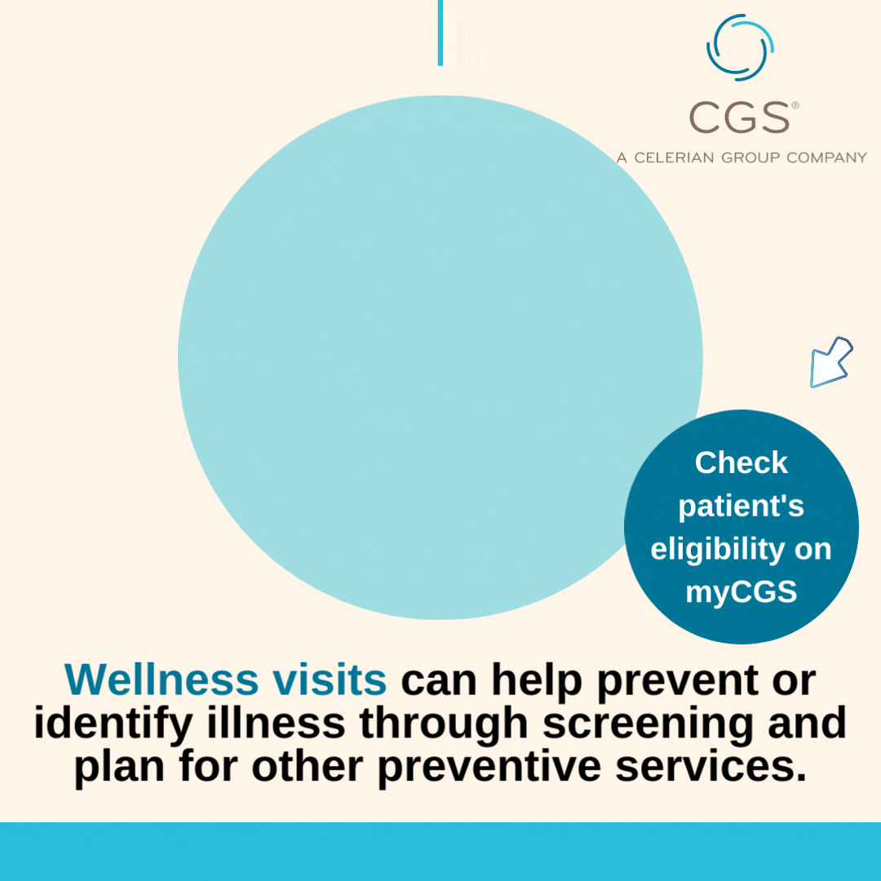
3: Link to edit 4: Link to edit
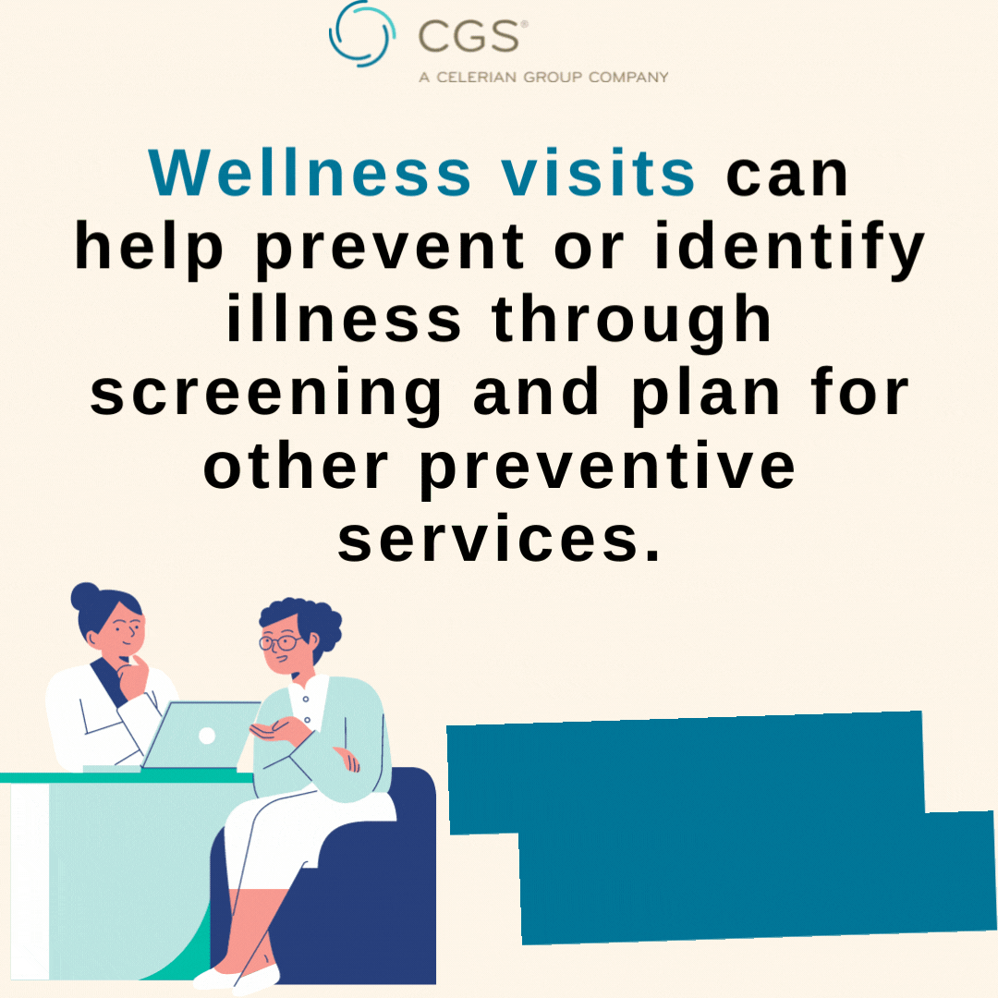

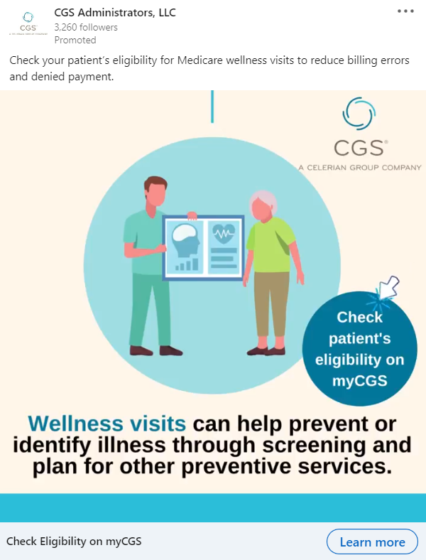
Social Media Ads

PSE Social Media Ad 1
Primary Text (106 characters): Check your patient’s eligibility for Medicare wellness visits to reduce billing errors and denied payment.
Headline (26): Check eligibility on myCGS
Call to Action (11): Learn More
Link: https://www.cgsmedicare.com/myCGS/Index.html


PSE Social Media Ad 2
Primary Text (106): Medicare wellness visits offer opportunities for health promotion, disease screening, and early detection.
Headline (41): Get started with Medicare wellness visits
Call to Action (11): Learn more
Link: https://www.cms.gov/Outreach-and-Education/Medicare-Learning-Network-MLN/MLNProducts/preventive-services/medicare-wellness-visits.html

Flyer

PSE Flyer 1
Link: https://cgsmedicare.com/pdf/j15/innovations/pse.pdf
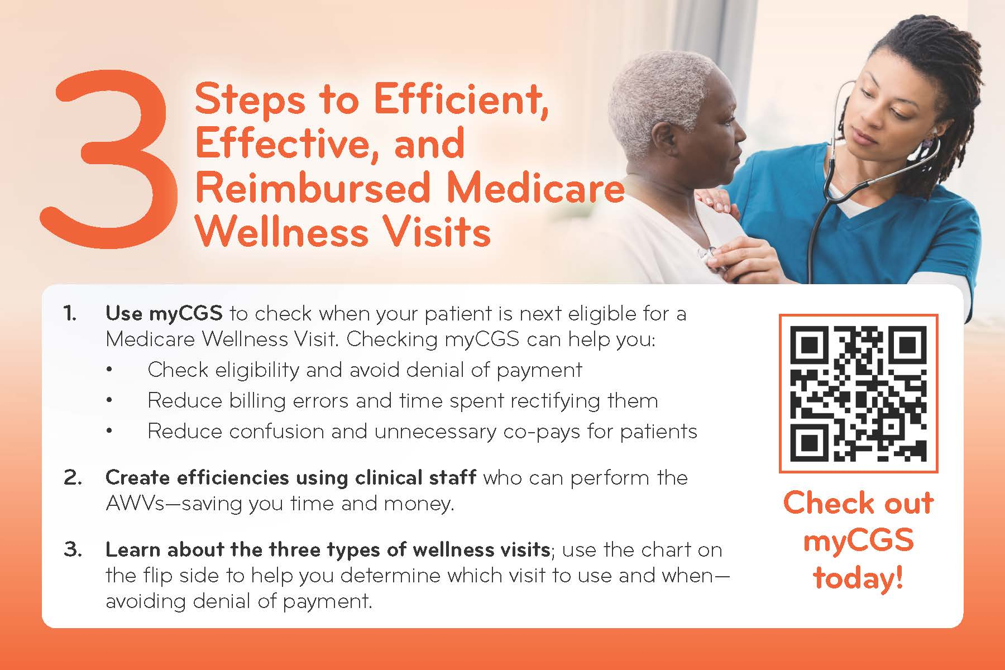
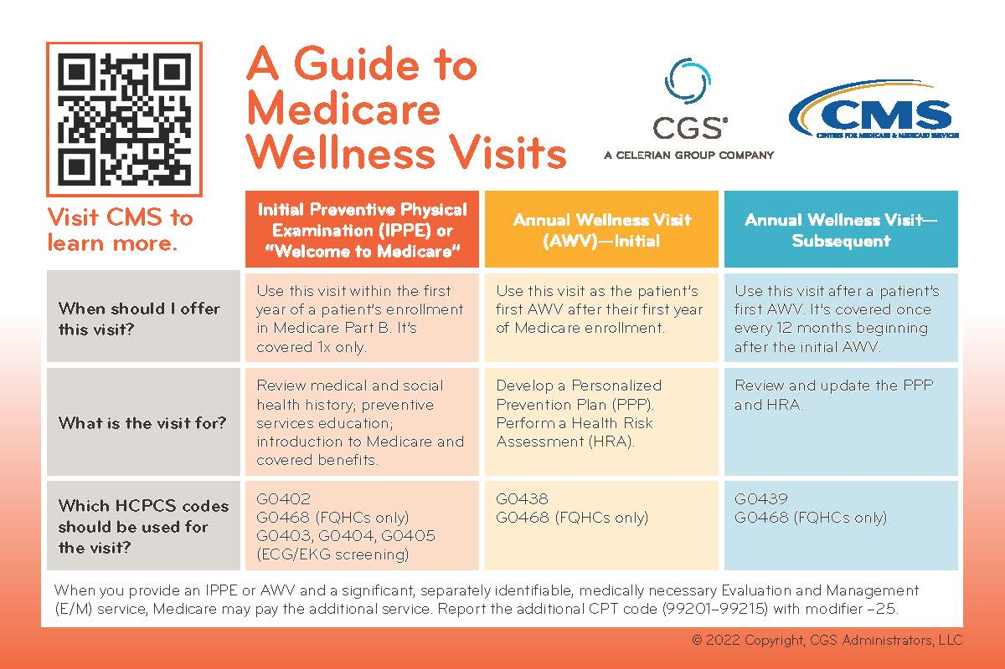

Videos

Using Medicare Wellness Visits to Promote Good Health
Link: https://www.youtube.com/watch?v=7sU2SdqPpvs

Centers for Disease Control and Prevention, National Center for Health Statistics. (2022). Leading causes of death. https://www.cdc.gov/nchs/fastats/leading-causes-of-death.htm

